Benjamin Lutter
11/02/2025
CSC450
Professor Bindu George

Module 8 Analysis - Concurrency Programs
For the CSC450 portfolio project, I implemented a basic concurrent program using two threads - one that increases a counter, and one that decreases it - in two languages, Java and C++. This highlighted the differences between these languages, with C++ being overall a lower-level and less abstracted language than Java - because of the additional control this provides, program implementations using C++ can be more performant, but this comes with the cost of extra vigilance in regards to security concerns, as improper resource management can result in security vulnerabilities or program errors such as resource leaks that are less common in Java due to the additional abstraction and tools like the JVM’s garbage collector.

Performance
In regards to performance, the C++ implementation would be considered more performant, though real-world performance differences are negligible with modern hardware at the scale of this project. The biggest performance difference comes from the fact that my Java implementation utilizes intrinsic locks (locks that are built into an object) with the synchronized keyword on it’s counter methods in order to ensure thread-safety, while the C++ implementation utilizes OS-level locks using std::mutex to achieve thread-safety. (Intrinsic locks and synchronization) The C++ implementation’s OS-level locks have less overhead than the Java implementation’s intrinsic locks, which includes a decision structure the JVM goes through to determine whether to use a light-weight locking mechanism (managed at the level of the JVM) or heavy-weight locking mechanism (managed at the OS level similar to C++ std::mutex locks). (Lock lock lock: Enter! 2013) Additionally, the JVM itself consumes some resources, making the Java implementation naturally less performant than the C++ implementation - the JVM must consume some memory and CPU cycles in order to perform capabilities like garbage collection and other features that make Java a more abstract language than C++.

Thread-Safety
As covered previously, in my C++ implementation, I ensured thread-safety using OS-level locks using std::mutex. In Java, I handled thread-safety using synchronization and the intrinsic lock Java assigns to objects by applying this synchronized keyword to the methods of my counter class. Overall, though the scope of this project was small and manually ensuring thread-safety in the C++ implementation was not too difficult because of that, the Java implementation could be considered “safer” and easier to implement, as locking and unlocking is abstracted and handled by the JVM - if I was creating a larger and more complex program, I definitely would have appreciated Java’s intrinsic locks and synchronization. In contrast, manually locking and unlocking resources as I did in my C++ implementation allows for a bit more customization and performance optimization on the behalf of the developer, but comes at a much higher risk of human error causing concurrency issues if you forget to lock/unlock a resource or lock/unlock at the wrong points in the program.

Security Concerns
Overall, the Java implementation can be considered more secure. Although the scope of the project is small and there is not too much to worry about with security in this program, Java’s abstraction allows it to be far more secure in general than C++. One of the weakest points for security for C++ is memory management, which is handled at a much lower level than Java, allowing it to be more performant and have less overhead, as memory management is performed manually by developers rather than automatically like in the JVM using garbage collection. This approach to memory management, coupled with C++’s use of explicit pointers that is not present in Java, makes C++ more susceptible to issues like memory leaks, as well as memory corruption and unauthorized access. Java’s more abstract approach also results in a larger suite of tools for ensuring program security, such as the SecurityManager class, which can be used to set security policies on the execution of potentially unsafe operations. (SecurityManager (Java Platform SE 8 ))

Conclusion
Overall, C++ can be considered to be preferable in scenarios where performance takes priority over security and code simplicity, as C++ is a lower level language and requires more intricate management of resources on behalf of the developer. Java would be preferable in scenarios where security is paramount, as the additional layer of abstraction via the JVM allows it to have many built-in security features and to avoid some key vulnerabilities in C++ related to memory access and management.

Works Cited
Intrinsic locks and synchronization. Intrinsic Locks and Synchronization (The JavaTM Tutorials > Essential Java Classes > Concurrency). (n.d.). https://docs.oracle.com/javase/tutorial/essential/concurrency/locksync.html
Lock lock lock: Enter!. It’s All Relative. (2013, March 25). https://jpbempel.github.io/2013/03/25/lock-lock-lock-enter.html
SecurityManager (Java Platform SE 8 ). (2025, October 20). https://docs.oracle.com/javase/8/docs/api/java/lang/SecurityManager.html

Source:
package csc450;
//Benjamin Lutter CSC450 Mod 8 Portfolio Project
class concurrencyCounter { //Counter class - uses synchronized methods to obtain a lock on the counter object, ensuring thread safety
private int counter = 0;
public synchronized void add() {
counter++;
}
public synchronized void sub() {
counter--;
}
public synchronized int get() {
return counter;
}
}
public class csc450portfolio {
public static void main(String[] args) {
concurrencyCounter counter = new concurrencyCounter();
Runnable increase = () -> { //Runnable to increase the counter in thread 1
while(counter.get() < 20) {
counter.add();
System.out.println("Thread 1 - Current step is: " + counter.get());
}
};
Runnable decrease = () -> { //Runnable to decrease the counter in thread 2
while(counter.get() > 0) {
counter.sub();
System.out.println("Thread 2 - Current step is: " + counter.get());
}
};
Thread thread1 = new Thread(increase);
Thread thread2 = new Thread(decrease);
thread1.start();
try {
thread1.join(); //thread1 join to prevent thread2 from decrementing the counter while thread1 is still incrementing, causing a race condition
}
catch(InterruptedException e) {
Thread.currentThread().interrupt();
System.err.println("Thread 1 interrupted.");
}
thread2.start();

}

}

Execution:
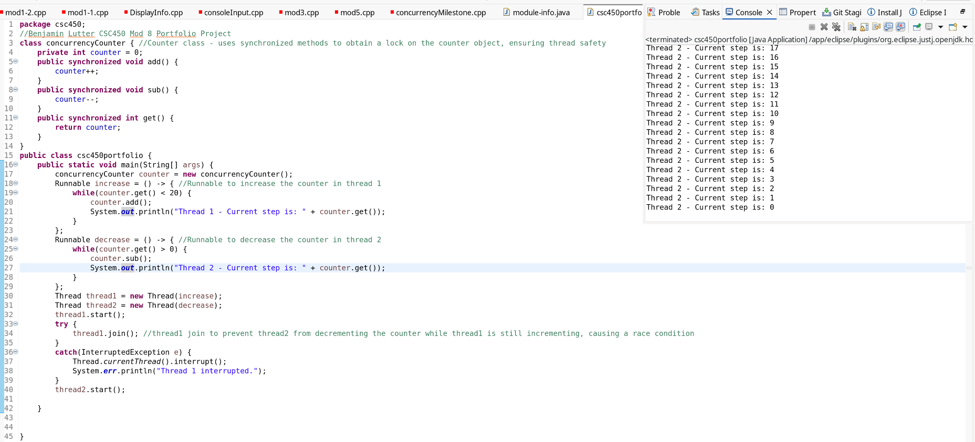
Git:
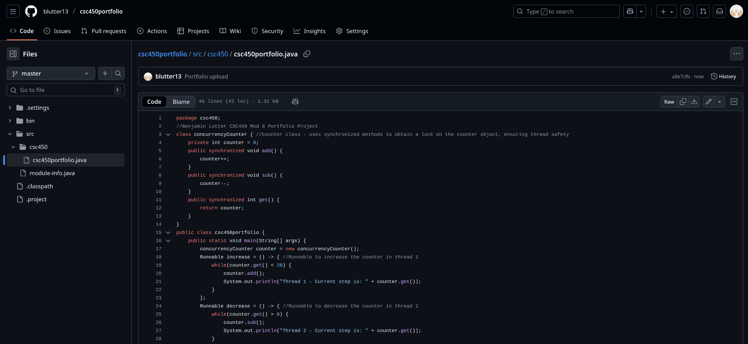
Link: https://github.com/blutter13/csc450portfolio/blob/master/src/csc450/csc450portfolio.java

